|  |  |
| --- | --- |
|  | PLTW_M_L_4CP |

|  |
| --- |
| **Project 6.1.6 Generators - VEX** |

Introduction

Many new technologies are being used to create electricity, but most power plants still convert rotary motion to electricity. Some obtain rotary motion from nature through wind turbines and hydroelectric dams. Most power, however, is generated from heat creating steam pressure that turns turbines to create rotary motion. About half of the United States’ power originates from power plants that burn coal to create heat. Other power plants create heat by burning natural gas, oil, diesel, and through nuclear reactions. To meet future energy needs, engineers are working hard to improve and create new technologies and to make existing systems cleaner and more efficient.

Equipment

* VEX Components
* Motor
* Hand crank
* 3-Wire PWM Y-Cable
* LED
* Various gears, structure and connecting parts
* Engineering notebook

Procedure

In teams of two or three, you will create a hand crank generator to create enough electricity to light an LED.

Constraints

* A hand crank will be used to provide power.
* A VEX motor will be used as the generator to light an LED.
* Only VEX components can be used.
* In order to light the LED, the motor must spin at a high rate of revolutions per minute (RPM). Gears are needed to increase RPM from the hand crank to the motor.
* Attach one leg of the Y Cable to the LED and the other leg to the Motor, as shown below.

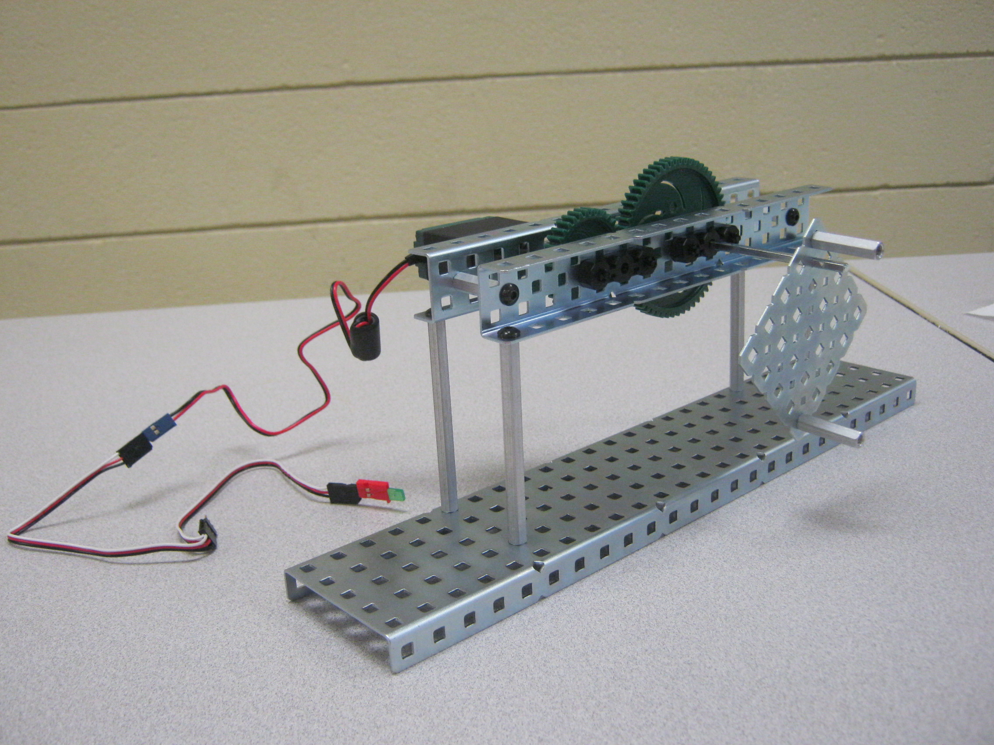

1. Use your GTT Engineering Notebook to record the following. All sketches should be created as outlined in the [Sample Engineer’s Notebook](file:///C:\Users\jdonnan\Desktop\GTT%202012\GTT%20-%20ME\GTT%20ME%202012_2013\ADV%20Teacher%20Resources\Sample_Engineers_Notebook_Entries.htm) document. Use the appropriate Design Process Templates to record your design brief, decision matrix and design solution steps.

* Record the gear combination you plan to use to increase the speed to the generator. Make a list of necessary support materials.
* Individually sketch three different ideas that could be used to create the generator. Be sure to include the crank, gear system, generator, LED, and support mechanisms for each.
* As a team decide your final design and create a final sketch. All team members should have a copy for their engineering notebooks. Present your final sketch to the instructor for approval.

1. Build a prototype of your design. If changes are made from the original design, changes must be documented in your engineering notebook.

Conclusion

1. What was the most difficult part of creating a successful generator?
2. Did you have to adjust the gear ratio from your original design?
3. What unique abilities or ideas did you provide to your team?